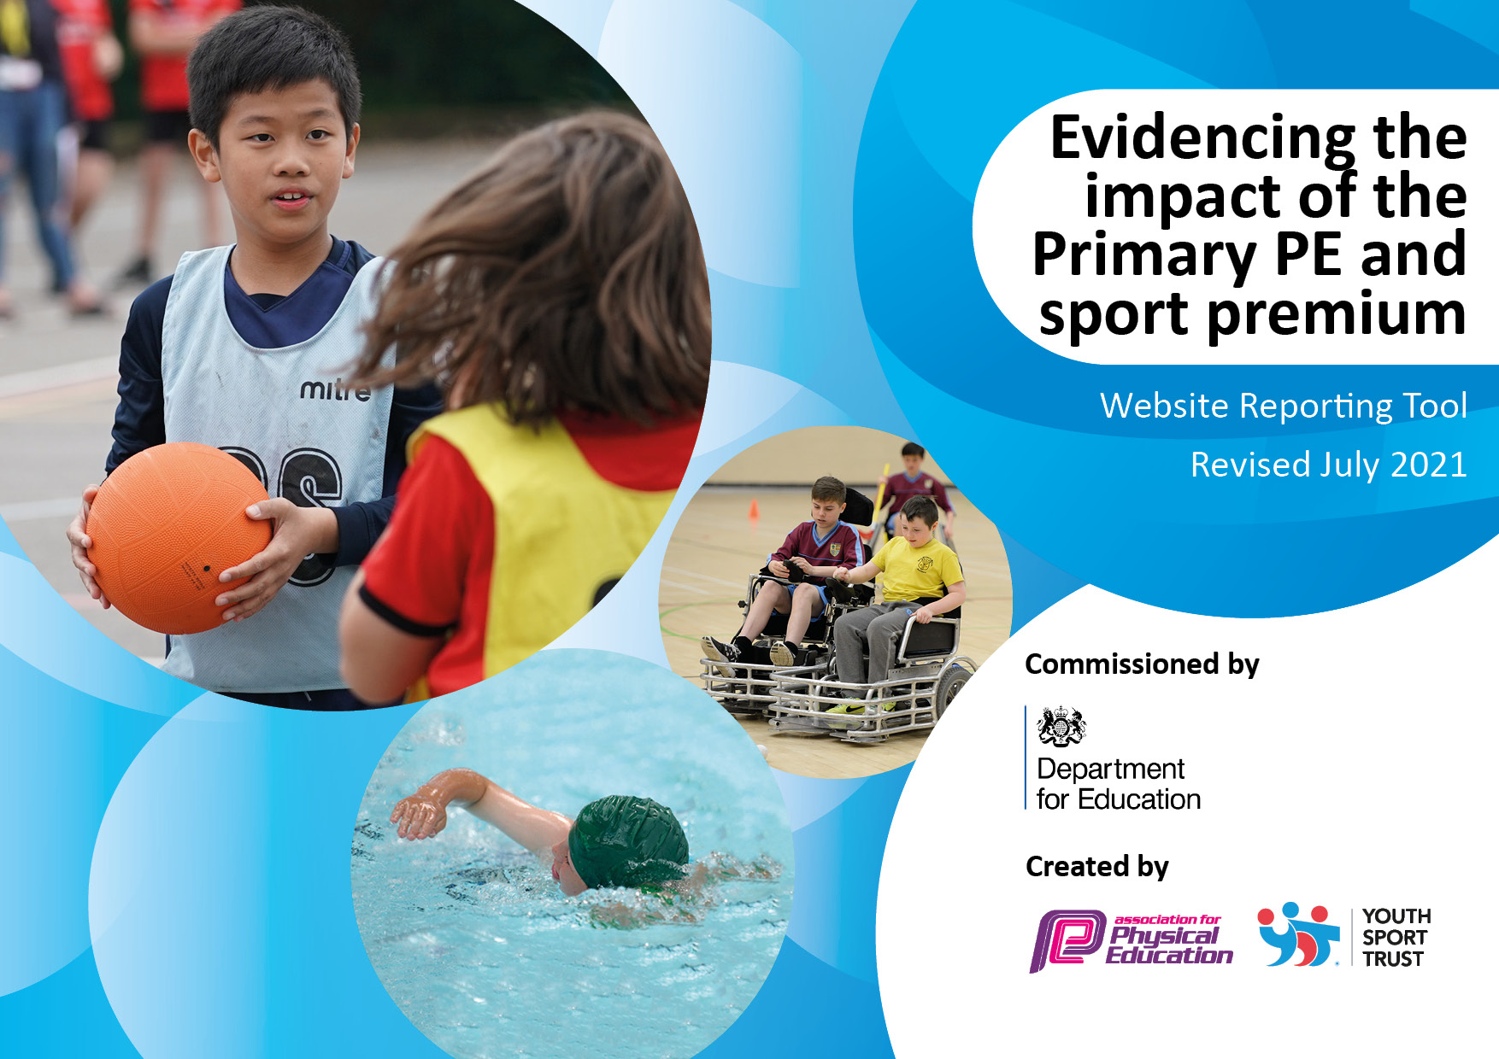

Revised September2023

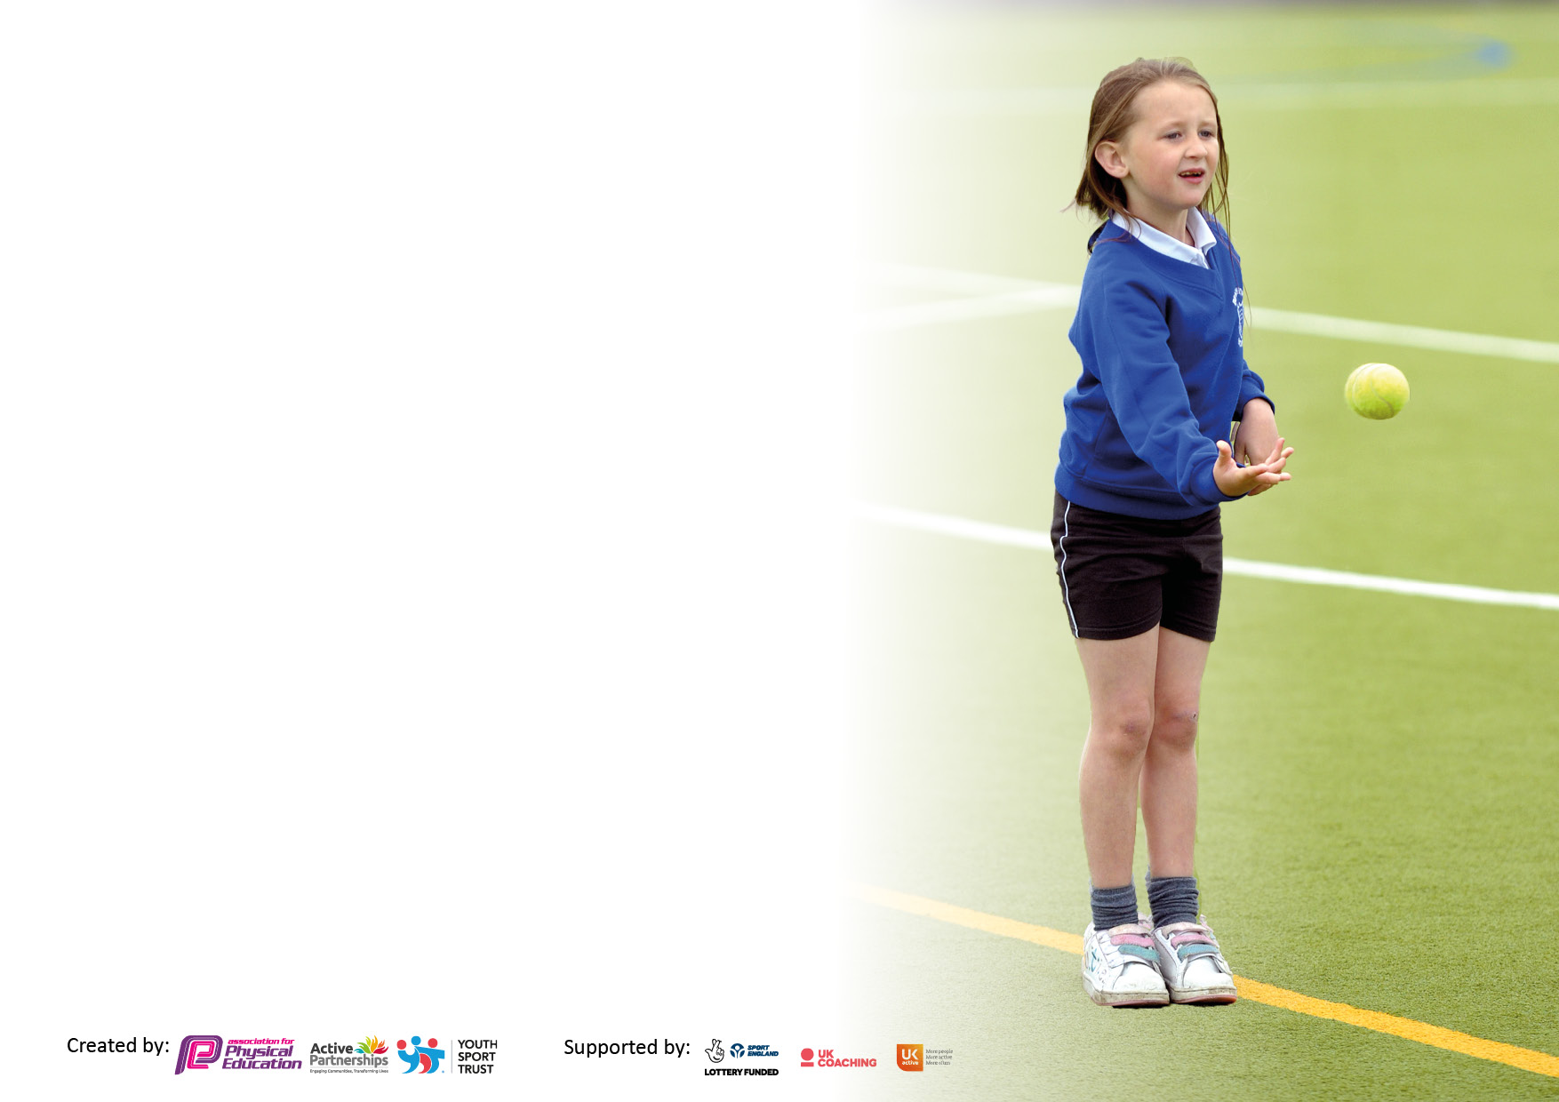

It is important that your grant is used effectively and based on school need. The [Education Inspection Framework](https://assets.publishing.service.gov.uk/government/uploads/system/uploads/attachment_data/file/843108/School_inspection_handbook_-_section_5.pdf) makes clear there will be a focus on **‘whether leaders and those responsible for governors all understand their respective roles and perform these in a way that enhances the effectiveness of the school’**.

Under the [Quality of Education](https://assets.publishing.service.gov.uk/government/uploads/system/uploads/attachment_data/file/843108/School_inspection_handbook_-_section_5.pdf) Ofsted inspectors consider:

**Intent** - Curriculum design, coverage and appropriateness

**Implementation** - Curriculum delivery, Teaching (pedagogy) and Assessment

**Impact** - Attainment and progress

To assist schools with common transferable language this template has been developed to utilise the same three headings which should make your plans easily transferable between working documents.

Schools must use the funding to make **additional and sustainable** improvements to the quality of Physical Education, School Sport and Physical Activity (PESSPA) they offer. This means that you should use the Primary PE and sport premium to:

* Develop or add to the PESSPA activities that your school already offer
* Build capacity and capability within the school to ensure that improvements made now will benefit pupils joining the school in future years
* The Primary PE and sport premium should not be used to fund capital spend projects; the school’s budget should fund these.

Please visit [gov.uk](https://www.gov.uk/guidance/pe-and-sport-premium-for-primary-schools) for the revised DfE guidance including the 5 key indicators across which schools should demonstrate an improvement. This document will help you to review your provision and to report your spend. The DfE encourages schools to use this template as an effective way of meeting the reporting requirements of the Primary PE and sport premium.

We recommend you start by reflecting on the impact of current provision and reviewing the previous spend.

We recommend regularly updating the table and publishing it on your website throughout the year. This evidences your ongoing self-evaluation of how you are using the funding to secure maximum, sustainable impact. Final copy must be posted on your website by the end of the academic year and no later than the 31st July 2021. To see an example of how to complete the table please click [HERE](http://www.afpe.org.uk/physical-education/wp-content/uploads/afPE-Example-Template-Indicator-2018-Final.pdf).

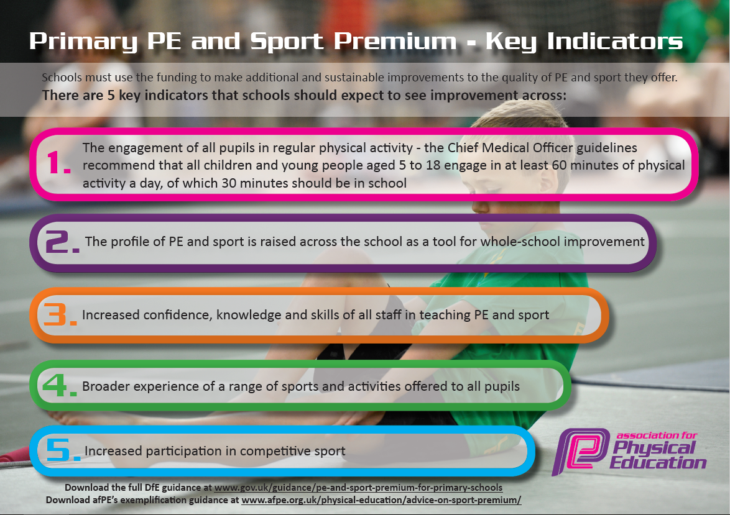



**Details with regard to funding**

Please complete the table below.

|  |  |
| --- | --- |
| Total amount carried over from 2021/22 | £ Nil |
| Total amount allocated for 2022/23 | £ 17,787.00 |
| How much (if any) do you intend to carry over from this total fund into 2023/24 | £ Nil |
| Total amount allocated for 2023/24 | £19,506.00 |
| Total amount of funding for 2023/24. To be spent and reported on by 31st July 2024. | £19,506.00 |

**Swimming Data**

|  |  |
| --- | --- |
| Meeting national curriculum requirements for swimming and water safety.  N.B. Complete this section to your best ability. For example you might have practised safe self-rescue techniques on dry land which you can then transfer to the pool when school swimming restarts.  **Due to exceptional circumstances priority should be given to ensuring that pupils can perform safe self-rescue even if they do not fully meet the first two requirements of the NC programme of study** |  |
| What percentage of your current Year 6 cohort swim competently, confidently and proficiently over a distance of at least 25 metres?  **N.B.** Even though your pupils may swim in another year please report on their attainment on leaving primary school at the end of the summer term 2023.  Please see note above | 86% |
| What percentage of your current Year 6 cohort use a range of strokes effectively [for example, front crawl, backstroke and breaststroke]?  Please see note above | 77% |
| **What percentage of your current Year 6 cohort perform safe self-rescue in different water-based situations?** | 72% |
| Schools can choose to use the Primary PE and sport premium to provide additional provision for swimming but this must be for activity **over and above** the national curriculum requirements. Have you used it in this way? | No |

**Action Plan and Budget Tracking**

Capture your intended annual spend against the 5 key indicators. Clarify the success criteria and evidence of impact that you intend to measure to evaluate for pupils today and for the future.

|  |  |  |  |  |
| --- | --- | --- | --- | --- |
| **Academic Year:** 2023/24 | **Total fund allocated:** | **Date Updated: 01.09.2023** | |  |
| **Key indicator 1:** The engagement of all pupils in regular physical activity – Chief Medical Officers guidelines recommend that primary school pupils undertake at least 30 minutes of physical activity a day in school | | | | Percentage of total allocation: |
| 41% £8,000 |
| **Intent** | **Implementation** | | **Impact** |  |
| Your school focus should be clear what you want the pupils to know and be able to do and about  what they need to learn and to  consolidate through practice: | Make sure your actions to achieve are linked to your intentions: | Funding allocated: | Evidence of impact: what do pupils now know and what can they now do? What has changed?: | Sustainability and suggested next steps: |
| Ensure that all children in all classes, upon return to school in September have the opportunity to take part in at least 30 minutes of physical activity per day by providing sports equipment for use during break & lunchtimes. | Purchase sets of outdoor play for each year group and storage bags equipment (footballs, netballs, tennis balls, skipping ropes etc…) for each class to use during morning break and lunchtime. Purchase outdoor metal containers to store equipment  Lost/damaged equipment to be replaced at the start of each half-term. | £2,500.00 | Greater active participation of all pupils across each year group. | Next steps after monitoring will be to establish any non-active pupils and promote further engagement for these pupils |
| Re-introduce and take part in the ‘daily mile’ initiative for pupils to increase physical activity rates | Lunchtime staff to ensure that pupils take part in the daily mile before the end of lunchtime. | £0.00 | Engage of all pupils in the mile a day initiative and greater activity | Determine the most effective time for this to take place and monitoring the impact on pupils |
| Continuation of Play Leaders scheme, during break & lunch times to provide greater opportunity for children to engage in 30 minutes of vigorous activity per day while in school. The aim is to continue the provision which has run successfully over the last 3 years. This involves training pupils to organise multi-sports competition as an alternative to the ‘Free-Play’ opportunities which already exist.  Each class to have at least one sports leader trained. | Sports Leaders to be trained through the REAL Trust play leaders scheme.  Playground zoned areas to be used to support the development of structured play as opposed to free play. Sports coach to support the development of play leaders and suggest games for them to implement on a weekly basis across the year age appropriate. | £1,000.00 | Promoting regular activity across the school day for all pupils in relation to structured play across year groups. | Monitor the engagement and success levels of play leader initiated activities. |
| A full program of extra-curricular clubs aimed at engaging all children across school in activities which support them in improving physical fitness, improving social skills and developing positive relationships with sport and physical activity. | Sports coach to provide an extra- curricular club every evening after school. The target group will change to ensure that all year groups have an opportunity to engage.  Targeted pupils will be identified in relation to DA and PP  External clubs will be sourced where necessary to provide the skill base eg. archery – costs may apply here | £2,000.00 | Target to reach those pupils who may difficult to engage in activity during the school day. | Closely monitor engagement and target pupil group for engagement. |
| School Sports Council  Half termly meetings of class councillors to enable pupil voice and continue to develop PESSPA from a child-centred perspective. | Council to meet half termly with PE staff and or sports coach where available to discuss health, activities and gain pupil voice in relation to sport fitness and PE | £1,000.00 | Ensure that the voice of the pupils is being heard in relation to engagement and delivery of physical activity within the school day. Act upon the views of pupils. | Ensure that pupil voice is being promoted -listened to and acted upon. |
| **Key indicator 2:** The profile of PESSPA being raised across the school as a tool for whole school improvement | | | | Percentage of total allocation: |
| 18% £3,570.00 |
| **Intent** | **Implementation** | | **Impact** |  |
| Your school focus should be clear what you want the pupils to know and be able to do and about  what they need to learn and to  consolidate through practice: | Make sure your actions to achieve are linked to your intentions: | Funding allocated: | Evidence of impact: what do pupils now know and what can they now do? What has changed? | Sustainability and suggested next steps: |
| School Sports Council  Half termly meetings of class councillors to enable pupil voice and continue to develop PESSPA from a child-centred perspective.  See key indicator 1 | Council to meet half termly with PE staff and or sports coach where available to discuss health, activities and gain pupil voice in relation to sport fitness and PE | £NIL  See key indicator 1 | Ensure that the voice of the pupils is being heard in relation to engagement and delivery of physical activity within the school day. Act upon the views of pupils. | Ensure that pupil voice is being promoted -listened to and acted upon. |
| PESSPA having high profile around school through displays in the hall and in communal areas | Displays to increase the profile of PESSPA across school for differing age ranges across the year and to celebrate success and achievement | £NIL | Raising the profile/awareness and impact of sports across school |  |
| Continue to hold and maintain the Gold Standard for the School Games Quality Mark as previously held since 2016 | Engagement of the PE Lead / Sports Council and Sports Coach in acquiring the Gold Standard in this aspect of the curriculum | £1,500.00 release of staff & award | Raising the profile/awareness and impact of sports across school and gaining external recognition | To continue to pursue excellence in this aspect of the curriculum |

|  |  |  |  |  |
| --- | --- | --- | --- | --- |
| **Key indicator 3:** Increased confidence, knowledge and skills of all staff in teaching PE and sport | | | | Percentage of total allocation: |
| 18% £3,550.00 |
| **Intent** | **Implementation** | | **Impact** |  |
| Your school focus should be clear | Make sure your actions to | Funding | Evidence of impact: what do | Sustainability and suggested |
| what you want the pupils to know | achieve are linked to your | allocated: | pupils now know and what | next steps: |
| and be able to do and about | intentions: |  | can they now do? What has |  |
| what they need to learn and to |  |  | changed?: |  |
| consolidate through practice: |  |  |  |  |
| Sports coach and PE Lead to up-skill and raise awareness and understanding of the crucial role support staff play in raising standards. | Ensured staff meeting time was allocated to disseminate to all support staff.  Joint/team working undertaken in order to build knowledge and confidence. | £500.00 to cover cost of TA cover overtime for attendance | • As a result of confident and knowledgeable support from TAs ALL pupils, irrespective of their special educational needs and disabilities to make excellent progress in line with their prior learning and ability.  • Impact across the curriculum as TAs confidence and self-belief develops and grows. | The subject leader will continue to work closely with the TAs and they will be included in staff meetings and professional development days with the focus being on effective support in all PE lessons and beyond. |
| Subject Leader to attend PE network meetings in order to up-skill her own knowledge and understanding so she can confidently disseminate to all staff, thus increasing their knowledge and confidence. | Liaise with SLT and sports coach to ensure staff meeting time was allocated in order to disseminate to staff.  Provided cover so SL could team teach/observe all members of staff at least once. | £1000 to supply cover cost of course/travel.  Cover to monitor staff delivery by SL. | • As a result of good leadership in the subject and confident and knowledgeable staff, all pupils made good or better progress, building on prior achievement.  • Increased confidence, self-esteem and a real desire to learn. The enjoyment of PE increased participation in wider activities | The subject leader will be allocated on-going staff meeting times; together with slots in professional development days to ensure all staff are kept up to date and that new staff are brought up to speed. |
| Ensure the 2 staff responsible for swimming attended appropriate course in order to support the teaching of swimming effectively. | Accessed appropriate course provided by the Local Authority in conjunction with the swimming provider in Heywood.  Ensured that cover was provided for other teachers to work alongside these two staff in order to gain knowledge and confidence. | £300 to fund course and pay for supply costs.  Purchase of Swim England resources. | • As a result it is expected that the standard at the end of primary school was reached by the majority of pupils  • Safe self-rescue competency to increase from  • Participation in water based activities to increase | There will be a rolling programme of staff who team teach with the two qualified staff which will ensure that in the future, with or without funding, teachers will feel confident to teach swimming to the expected level required. |
| Employed a member of the afPE Health and Safety team to deliver a workshop (January) for all staff in Safe Practice using the afPE publication as a basis for risk assessment and safety in all areas of activity both in the curriculum and in out of school clubs. | Contacted the afPE office and booked a full day workshop in O=January with one of the H&S team during one of the 5 allocated Professional Learning Days for the primary schools.  N.B. Possibly when the new guidance is published if funding is still available undertake a further development workshop. | £900 including money reserved for purchase of new Safe Practice book per school. | • All staff are confident in ensuring all safety requirements are met and as a result all pupils feel safe and secure; this encouraged them to challenge themselves to go the extra mile, thus improving their overall attainment.  • Feeling secure in the school environment impacted on whole school improvement as pupils developed the 'can do' attitude and a willingness to try harder. Pupil survey evidenced a 100% feel good factor and there have been very few cases of 'stressed out' pupils. Visitors remark on the happy working environment in school. | The subject leader will ensure that staff are kept up-to-date through staff meetings and dissemination of information that is readily available on the afPE website or through contact with the H&S team which is open to all members (See comment about joining afPE below). |
| Join afPE (School Membership) to ensure access to specialist and expert support, thus keeping the school fully up to date. | Access membership information on afPE website and spoke to Simon Leach to ascertain relevant information regarding cost/benefits/etc. | £100.00 | • Due to the wide ranging expertise within afPE which is readily available to members, all pupils will benefit from knowledgeable and confident staff who are kept up to date with all developments. The subject leader, the staff and most importantly the pupils now keep ahead of all developments.  • 100% of pupils to articulate the difference between PE, Sport and Physical Activity.  • Termly pupil surveys demonstrate an increase in physical activity of pupils | Membership will be renewed each year from the school budget if PE and Sport funding is discontinued. |
| Provide further training opportunities for staff who deliver PE sessions/extra-curricular clubs. | Identify areas of weakness in terms of subject delivery and source CPD opportunities either through School Sports Partnership or external provider. | £750 membership fee  Rochdale Schools Partnership (includes a variety of CPD opportunities throughout the year) | Increase knowledge of staff to enable them to deliver extra-curricular and PE sessions with greater confidence | Succession planning of staff to be able to lead on extra -curricular clubs in school. |
| **Key indicator 4:** Broader experience of a range of sports and activities offered to all pupils | | | | Percentage of total allocation: |
| 17% £3400 |
| **Intent** | **Implementation** | | **Impact** |  |
| Your school focus should be clear | Make sure your actions to | Funding | Evidence of impact: what do | Sustainability and suggested |
| what you want the pupils to know | achieve are linked to your | allocated: | pupils now know and what | next steps: |
| and be able to do and about | intentions: |  | can they now do? What has |  |
| what they need to learn and to |  |  | changed?: |  |
| consolidate through practice: |  |  |  |  |
| Update PE resources to ensure that all children have access to high-quality equipment and a broad and varied curriculum. | Purchase of equipment for a range of sports.  Prioritising:  Football  Gymnastics Mats and benches  Cricket  Badminton Rackets | £1,400.00 | Updated equipment to support the delivery of PE  Range of sports on offer extended | Developing the range of activities, sports we can offer alongside the safety of pupils using the equipment. |
| Zone marking in the playground and upkeep of school field. This will enable PE staff to deliver a programme of outdoor sport in terms 1 & 2 to all year groups with a focus on:  Developing pupil’s physical fitness post-lockdown.  Whole class games and activities  ‘Catch-up’ lessons targeting NC activities | Regular discussion with grounds maintenance team to prepare work area for lessons/topics  200m track for athletics lessons.  Funding pot designated for pitch markings.  Sports Coach to oversee the deliver a range of activated in the designated zone across the week for all year groups | £1000.00 | The zones within the playground will support pupils to determine their level of activity day on day.  The reading and quiet area / self-initiated activities led by play leaders and the provided activity for all year groups | Pupils have the opportunity to apply skills from PE lessons to outdoor provision in a structured and zoned area to minimise any potential hazards. Levels of engagement continue to increase. |
| Extra-curricular activities offered to provide a greater range of sports and activities | PE Lead to liaise with external providers of wider range of activities such as: fencing, archery etc. | £1000.00 | Offer a range of activities to all year groups across the year | As above |

|  |  |  |  |  |
| --- | --- | --- | --- | --- |
| **Key indicator 5:** Increased participation in competitive sport | | | | Percentage of total allocation: |
| 5% £ 1000 |
| **Intent** | **Implementation** | | **Impact** |  |
| Your school focus should be clear | Make sure your actions to | Funding | Evidence of impact: what do | Sustainability and suggested |
| what you want the pupils to know | achieve are linked to your | allocated: | pupils now know and what | next steps: |
| and be able to do and about | intentions: |  | can they now do? What has |  |
| what they need to learn and to |  |  | changed?: |  |
| consolidate through practice: |  |  |  |  |
| Fund membership of both Rochdale Borough School Sports Partnership and Middleton Primary School Sports Partnership – enables access to wide range of competitive sporting opportunities including SEND specific events. | Pay annual membership subscriptions for Rochdale Schools Partnership and Middleton Primary Schools Sports Association. | £750  Rochdale Borough Sports Partnership membership fee (Cost recorded in Key Indicator 2) | Pupils are able to participate in a wide range of sporting activities across the locality and borough This gives more opportunities to apply their knowledge and skills in a competitive and non-competitive arena. | More collaborative offer of PE and sports clubs to enable more pupils to participate. Play and work alongside pupils forma variety of school contexts, developing relationships etc |
| Provide transport for school teams to enable children to access sport both in their local community and within the borough | Arrange minibus to collect and return pupils to events when necessary. | £250 contribution towards mini-bus costs (deficit paid through school funds) | Ensure all pupils have access to sporting events without the barriers of travel expenses, parents missing work etc | Participation through a more inclusive model for all pupils. |

|  |  |
| --- | --- |
| Signed off by | |
| Head Teacher: |  |
| Date: | Reviewed September 2023 |
| Subject Leader: | Miss M Ingram |
| Date: | Reviewed September 2023 |
| Governor: |  |
| Date: | Reviewed September 2023 |

